**What is soldering?**

Soldering (pronounced “soddering”) is the process of joining two pieces of metal together by melting solder. The solder and pieces of metal are heated up by the soldering iron. Soldering can be used to make jewelry, reconnect wires and components back together, or to hold them in place in a circuit board!

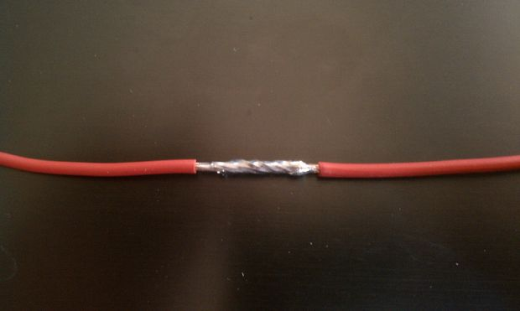

**What is solder?**

Solder is a metal alloy that is typically made out of combinations of tin, copper, and sometimes silver! A lot of the time, there is flux in the core of solder. The flux in solder fights against the metal oxide coatings of the pieces of metal being soldered. If there was no flux, the metal oxide coatings would prevent the solder from “wetting” or sticking to the surface of the metal, making it impossible to solder two pieces together. For electronics a rosin core flux is usually used. When heated, the flux in the solder produces smoke. Fume extractors are good practice to prevent you from breathing in the smoke produced by the flux.

**Why does the solder melt but not the copper?**

Solder has a much lower melting point than copper. When soldering, the soldering iron is heated to 750°F, which is above the melting point of the solder and turns the solder into a liquid. Copper melts at 1,984°F and we solder at 750°F, which is less than the melting temperature of copper, so it stays solid.

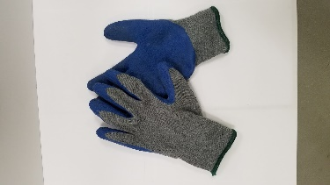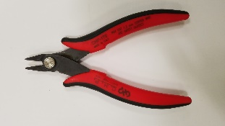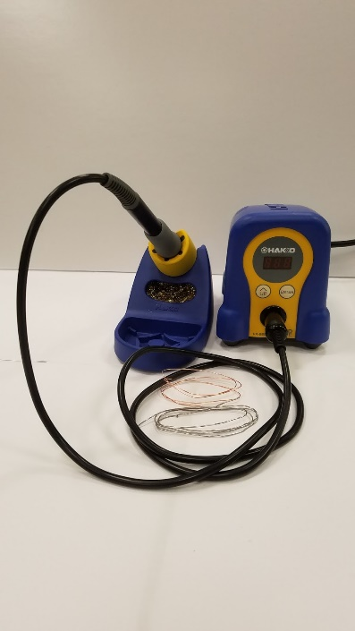**What tools do we need?**

* Soldering iron
* Solder
* Copper
* 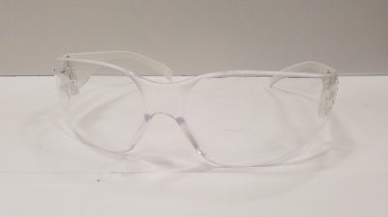Wire cutters
* Gloves
* Safety glasses
* Tape

**Safety**

The soldering irons heat up to 750°F, this is greater than 3 times the temperature water boils at, so be careful! You must wear gloves at all times while soldering, but you can take them off to cut/tape the copper wire. Never touch the metal end on the soldering iron, that is what heats up. The rubber/plastic handle is okay to hold, but be cautious your finger doesn’t slip onto the metal part. Safety glasses must be on at all times to prevent pieces of wire from getting in your eyes!

**How do you solder?**

1. Hold the soldering iron on the joint you want to solder for about a second to heat up the copper. This will help the solder stick to the copper better!
2. Bring the solder to heated up joint and push it in so that it melts around and fully “wets” or sticks to the copper wire.
3. Remove the soldering iron from the joint and put it back in its stand. If you keep the soldering iron on your joint for too long you might burn the solder or components!

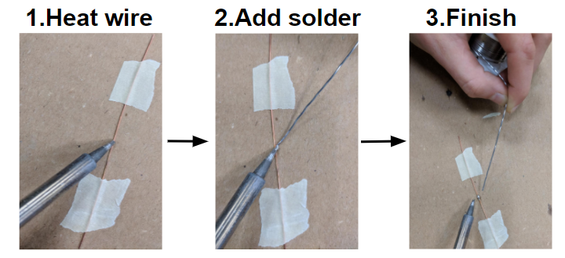

**What does an awesome solder joint look like?**

* It doesn’t have too much solder, less is more!
* The solder wasn’t overheated/burnt so it is nice and smooth.
* 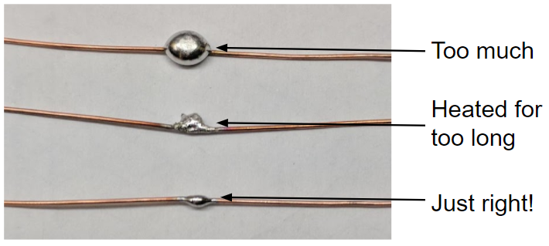It is super strong and cannot be pulled apart!

**Keeping your iron clean**

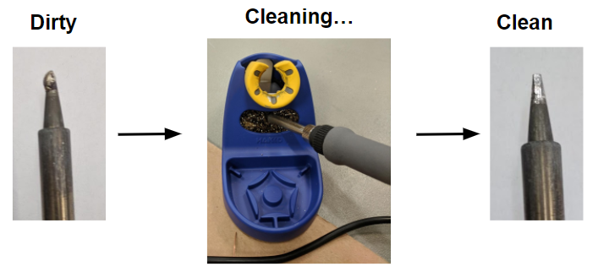Remember to continuously clean your iron, if it gets dirty the solder tends to stick to the soldering iron instead of the copper and can be very frustrating!

**Let’s try it!**

To start soldering, find a mentor and ask them to show you what to do! We will start by soldering two wires together for practice and then we will make a square and turn it into a cube!

**Soldering two wires together**

1. Cut two pieces of copper, about 2 inches long.

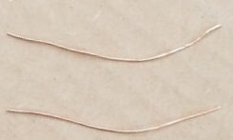

1. Straighten both pieces of copper by rolling under a block of metal. For best results, don’t be afraid to press down hard on the metal block while rolling!

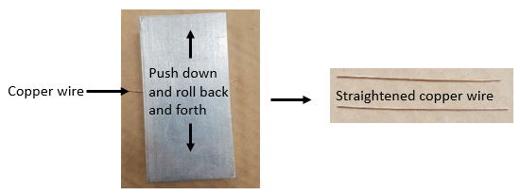

1. Tape both pieces of copper down so that the ends are touching and form a straight line. Be sure to keep the tape off of the point they connect, that is where we are going to solder!

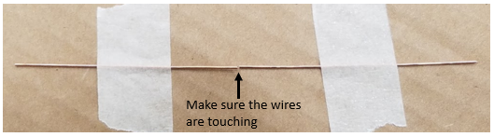

1. Solder the wires together where they are touching.

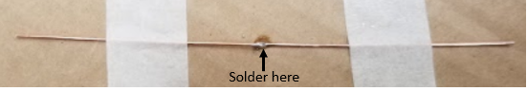

1. You did it! Untape the newly formed wire and try to pull it apart. If you can pull it apart you might need to work on your technique a little, go ahead and try it again!

**Making a cube**

1. First let’s make a square! Since a square has 4 equal sides we need to cut 4 equal pieces of copper wire. Straighten each piece out, if you need a refresher see step 2 of **Soldering two wires together**. Once straightened you might notice that the lengths are not exactly equal, if this is the case trim them as shown in the picture below!

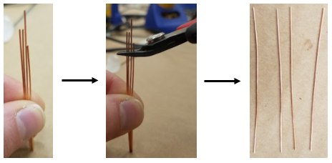

1. Tape the 4 pieces of copper wire down in the shape of a sqaure. Make sure the corners are touching. When you’re ready, go ahead and solder each of the corners!

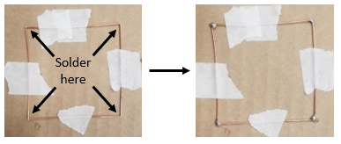

1. Repeat steps 1 and 2 to create another square. Leave both squares taped down for the next step!

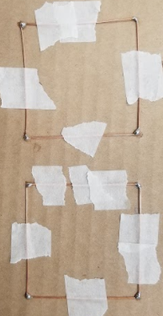

1. Repeat step 1 so you have 4 more eqaul pieces of copper, but this time we will use the copper to connect the 2 sqaures, creating a cube. It’s helpful to have a friend hold the wire up with a pair of pliers while you solder it in place as shown below. Once the first side is done, untape it and flip it over to solder it to the other sqaure, completing the cube!

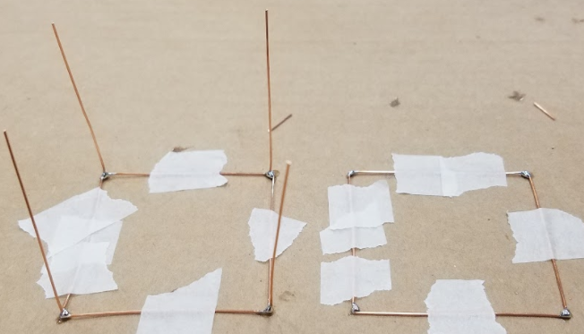

1. Once step 4 is complete, untape the square with legs and flip it over to finish the cube. Congratulations, you soldered a cube!

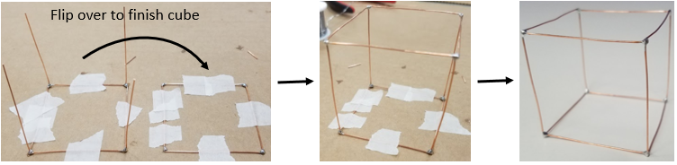

**Create your own design with soldering**

You have just finished your cube, now come up with your own project and create it! Here are some ideas:

